**MUHAMMAD HASSAN IRFAN**

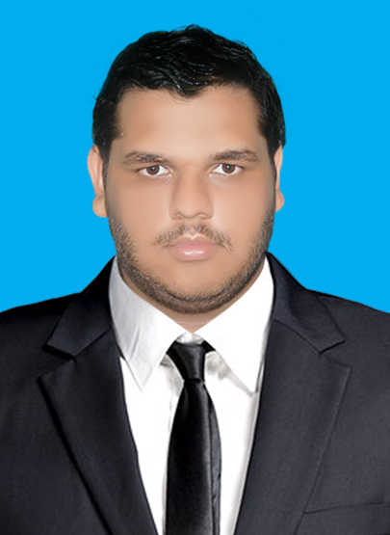

Block-I C/155 North Nazimabad**,** Karachi

03322907494 [hassanirfan263@gmail.com](mailto:hassanirfan263@gmail.com)

CNIC**:** 42301-2154454-9

**__________________________________________________________________________________________________________________________________________________________________________________________________________________________________________**

**SUMMARY OF QUALIFICATIONS**

* Attained D.A.E in Electrical
* Proficient in Microsoft Word, Excel and Power Point

**EDUCATION**

**B.S Electrical (4 years program)** on going

Dadabhoy Institute of Higher Education

North Nazimabad, Karachi

**D.A.E Electrical (3 years program) with B Grade** 2016

Govt. Saifee Eide Zahabi College of Technology, Tevta

North Nazimabad, Karachi

**S.S.C Part I and II MATRICULATION with B Grade** 2013

Bahria Foundation School

Gulshan-e-Iqbal Campus, Karachi

**SKILLS**

**Programs:** Command on MS Word, PowerPoint and Excel**.**

**Management:** Organized many different events in School**,** performed

as a team leader.

**WORKED EXPERIENCE**

Worked as a computer operator at **ASK Pure Drinking Water CO.**

**2016-2017**

Working as Maintenance Electrician at **MAMJI Hospital.**

**ACHIEVEMENTS**

* Organized an event **, The Fun Gala , Bahria Foundation School , 2013**
* Participated as a cricket team Captain **, Annual Sports Day , Bahria Foundation School , 2012**
* Participation certificate **, Intra Campus Competition, Bahria Foundation School , 2011**
* Performed a leading role in skit **,** **Best skills in Acting , Bahria Foundation School , 2007**
* Secured **3rd position in final examination, Zaheer Public School.**
* Secured first position in **Well Dress Competition, 2001**